LG: to punctuate speech correctly
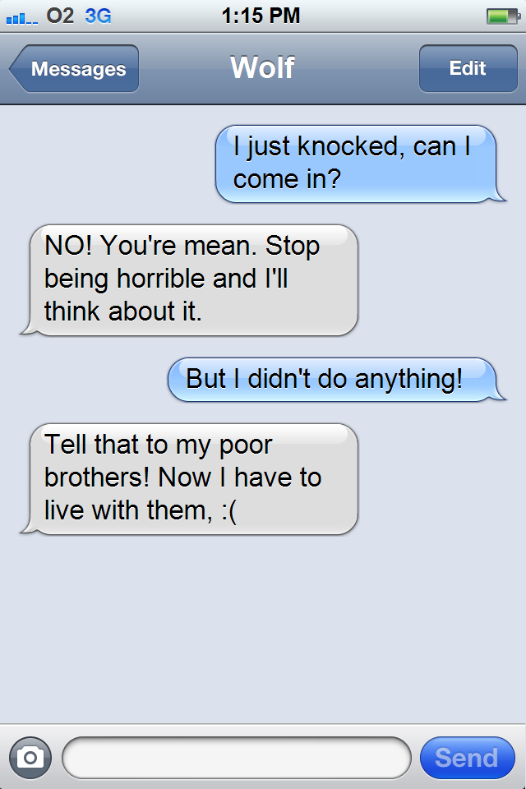

Copy out this conversation using correct speech punctuation – speech marks AND a new line for a new speaker.
Remember to change your “said” word and add in an adverb (how was it said?)

LG: to punctuate speech correctly
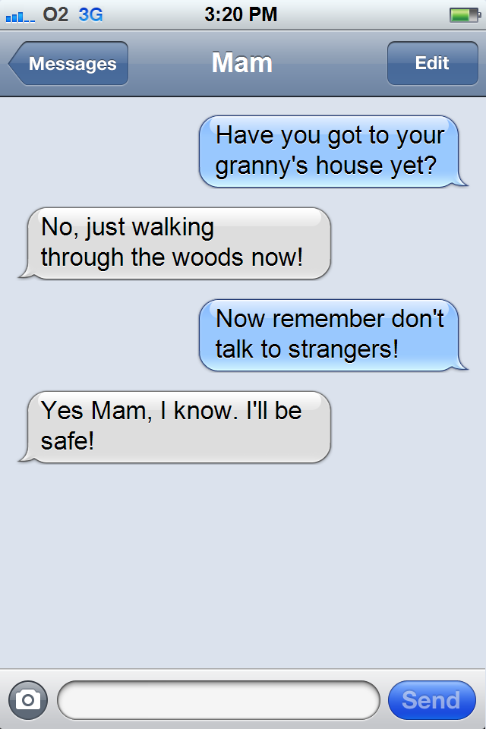

Copy out this conversation using correct speech punctuation – speech marks AND a new line for a new speaker.
Remember to change your “said” word.

LG: to punctuate speech correctly
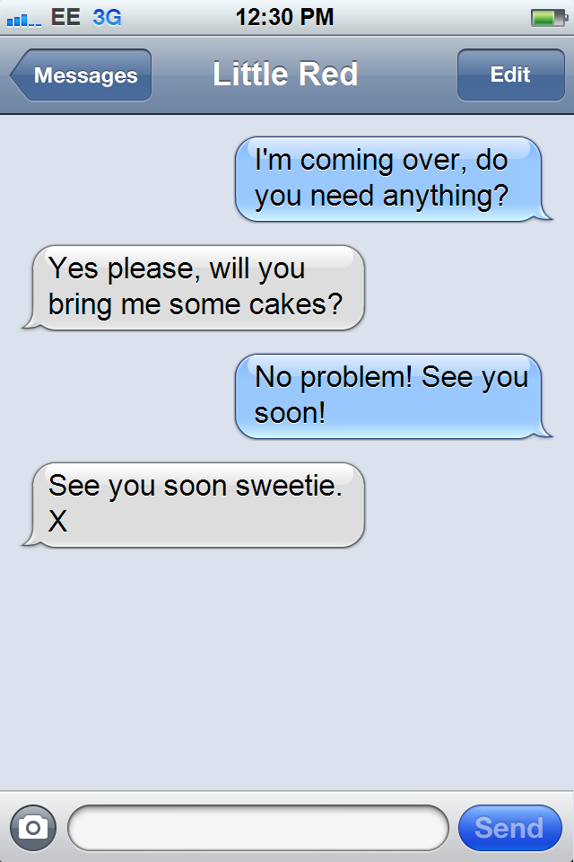

Copy out this conversations using correct speech punctuation – speech marks AND a new line for a new speaker.
Remember to change your “said” word.

